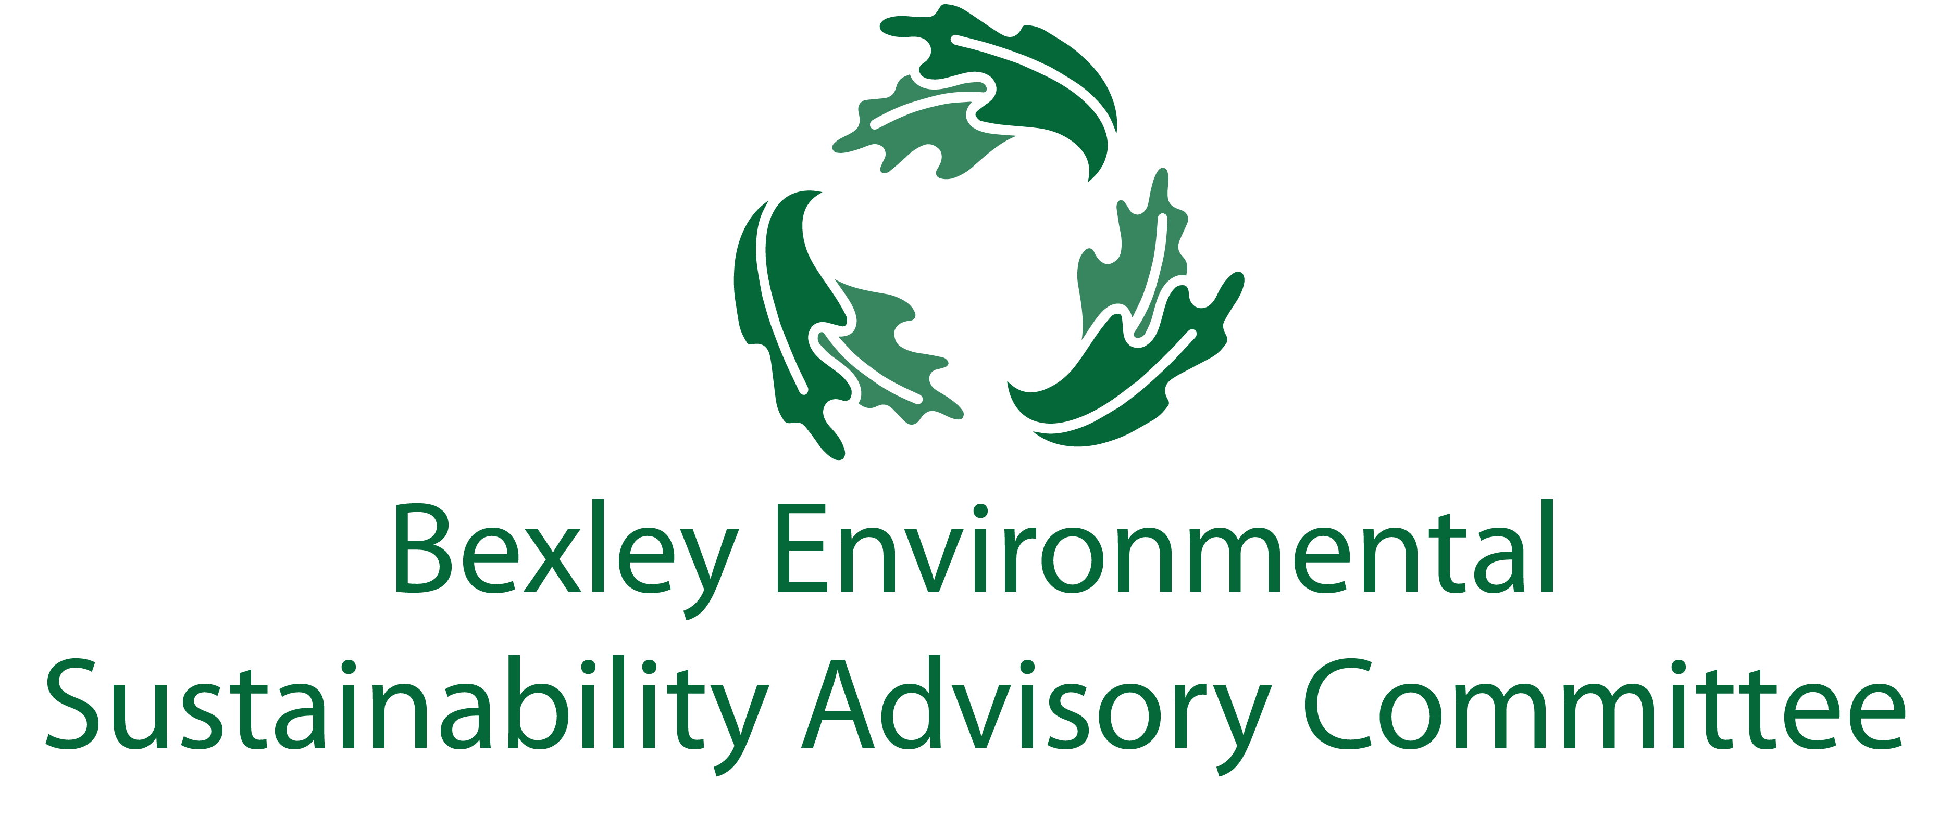

November 19, 2018

6:00 pm, Bexley City Hall

Meeting Agenda

Roll Call & Introductions

Plastic Bag / Single Use Plastic Ordinance – Troy

Food Waste Recycling program update & next steps / ESAC involvement

Greater Bexley Cleanup Day – April 27

Other Major Goals Updates

Food waste recycling community outreach - Joanna and Jo Anne

Community education regarding plastic bag use – Jo Anne and Troy

Communications update – Elizabeth

Chamber update – Lesli Mautz

Prioritize Reduce & Reuse before even "Recycle" + add "Rethink" | Captains
Roll out community-wide food waste recycling | Joanna, Jo Anne
Have a committee of the schools - Capital, CSG, Bexley Schools, St Charles | Jim, Paul
Single Use Plastics Ban - research and promote | Troy, Ben, Jo Anne
Mandatory commercial and MF recycling | Carol, Ben
Web-based directory of recycling options & explore needs for Bexley - Promote alternative recycling options (i.e. Gimme 5, corks, etc) | Elizabeth, Steve, Sam M.
Educate community on waste management | Elizabeth

Climate
Help promote PACE solar program | Drew, Steve, Ben

Education/Outreach
Environmental Fair - help promote with some "giveaways", maybe semi-annual? | Elizabeth, Carol
Badges/seal for waste management practices for businesses | Lesli, Joanna

Leadership of ESAC – revisit Chair concept

Free Thinking – Big Ideas Brainstorm Time

Adjourn

Next meeting is January 15 at 6:00 pm at City Hall

