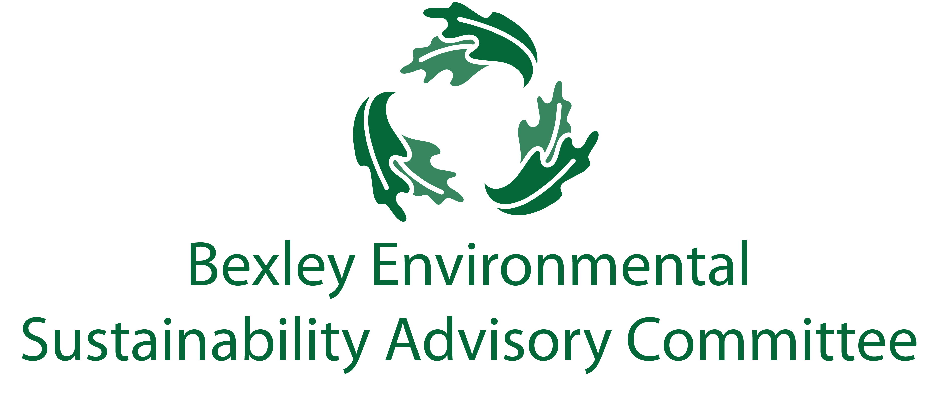

September 20, 2018

6:00 pm, Bexley City Hall

Meeting Agenda

Roll Call & Introductions

Ohio EPA – exploring partnerships

Major Goals Updates

Food waste recycling community outreach - Joanna and Jo Anne

Community education regarding plastic bag use – Jo Anne and Troy

Draft ordinance for plastic bag ban – Ben

Solar PACE program update – Ben

Communications update – Elizabeth

Other Updates I haven’t listed?

Prioritize Reduce & Reuse before even "Recycle" + add "Rethink" | Captains
Roll out community-wide food waste recycling | Joanna, Jo Anne
Have a committee of the schools - Capital, CSG, Bexley Schools, St Charles | Jim, Paul
Single Use Plastics Ban - research and promote | Troy, Ben, Jo Anne
Mandatory commercial and MF recycling | Carol, Ben
Web-based directory of recycling options & explore needs for Bexley - Promote alternative recycling options (i.e. Gimme 5, corks, etc) | Elizabeth, Steve, Sam M.
Educate community on waste management | Elizabeth

Climate
Help promote PACE solar program | Drew, Steve, Ben

Education/Outreach
Environmental Fair - help promote with some "giveaways", maybe semi-annual? | Elizabeth, Carol
Badges/seal for waste management practices for businesses | Lesli, Joanna

Free Thinking – Big Ideas Brainstorm Time

Adjourn

Next meeting is October 16, 2018 at 6:00 pm at City Hall

Coming Up:

October 25th MORPC Sustainability Summit

Goals:

Website live for recycling resources

Flyer

