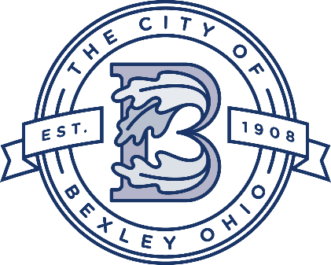

Service Department Update
Service Director
Andy Bashore
October 28th, 2025
Street Department:
The crews have started working on our annual leaf removal program. They are also finishing up a few concrete repairs and asphalt patchs.

Water and Sewer Department:
The water and sewer crews are working on the lead line inventory program and also replacing mtu’s .

Urban Forestry/Grounds Maintenance:
The crews are performing tree maintenance and groundwork throughout the city, crews have also started to work on stump removals.

Utility Crew:
The crew has been working on replacing street signs and street lights throughout the city.

2025 Street Project
The project is wrapping up, Bexley Park and Sherwood have been paved. Brick repairs on Bryden, Bexley Park, and North Roosevelt are complete.

2025 Sidewalk Project
The project is almost complete.

North Columbia Project
The project is underway, and is now in the final phase. The new water main line has been installed. The concrete work is finished and the paving work is currently underway.

South Remington Water Line Project
The project has started-currently working in the block between Charles and Livingston. The waterline portion should be completed in late spring 2026 and paving will follow.

Columbia Gas Project
Columbia Gas is currently working on Euclaire,Charles, and South Cassingham,the project should be complete in two weeks.

