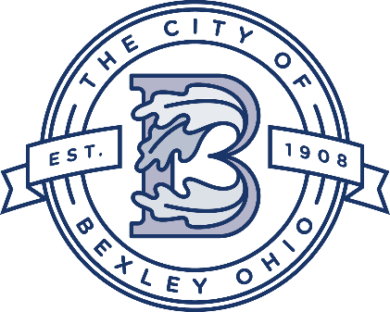

Service Department Update
Service Director
Andy Bashore
October 24th, 2023

Street Department:
The crews are finishing asphalt patches throughout the city. Also, the crews started the 2023 leaf season yesterday, the crews will run 3 trips around the city and should be complete in late December.

Water and Sewer Department:
The Water/Sewer crew has been working on videoing the city’s main lines and looking for issues and identifying lines for future lining projects. The crew is pumping out fire hydrants and hydrant inspections. The crew is also working on a back log of MTU replacements.

Urban Forestry/Grounds Maintenance:
The crews are doing tree maintenance and ground work throughout the city. Also, the crews have starting working on stump removals.

Drexel Project
Drexel-Main to Broad-The project is wrapping up, the contractor is finishing touch up and clean up work. The asphalt paving will take place in Spring 2024.

2023 Sewer Lining Project
Currently working on the bid package.

2023 Street Project
The project will be starting next week.

Grandon Ave- Water Line Project
The project is underway and the contactor is working between Mound and Main for the next couple of weeks. Project is expected to be complete in late-October.

Chelsea Ave-Water Line Project
The project will start in early November.

2023 Sidewalk project
The project will be starting mid-October.

Columbia Gas Main Replacement Projects:

The project is underway and the estimation completion of the project is early November.

Columbia Gas of Ohio will be providing a map and schedule to each resident of the affected streets. These streets include:
College Avenue from Livingston to Astor
Astor Avenue from College to Pleasant Ridge
Pleasant Ridge Avenue from Astor to Francis Avenue
Francis Avenue from Pleasant Ridge to Livingston.

