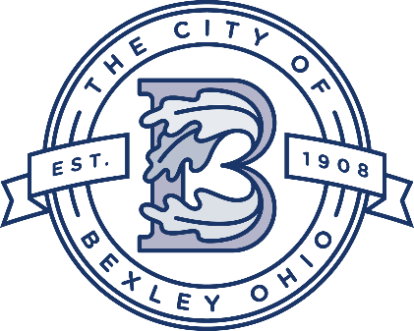

Service Department Update
Service Director
Andy Bashore
June 27th, 2023

Street Department:
The crews are working on brick repairs. Also, the crews are working on asphalt patches throughout the city. The crew has begun preparations for the July 4th celebration.

Water and Sewer Department:
The Water/Sewer crew have finished the valve turning program. The crew has been working on videoing the city’s main lines and looking for issues and identifying lines for future lining projects. The city’s annual hydrant flushing program was completed last week.

Urban Forestry/Grounds Maintenance:
The crews have finished the City’s dog park. Also, the crews are doing tree maintenance along the parade route.

Drexel Project
Drexel-Main to Broad-The concrete work is underway which will include curbs, medians, and bump outs. The bump outs are complete up to Bexley Park. Two medians were installed between Sherwood and Bexley Park. This week the contractor will be working on the west side and will be installing bump outs from Bexley Park to Broad Street.

2022-2023 Sewer Lining Project
Sewer Lining and Rehabilitation:

The lining of the Storm Sewer on College Avenue (South of Mound) is finished. The Storm and Sanitary Sewers on Astor Avenue (between Pleasant Ridge and College) is complete. The 2023 project will go out to bid in late August.

2023 Street Project
The project will be starting after July 4^{th.}

Grandon Ave- Water Line Project
The project is underway.

2023 Sidewalk project
The project will be starting in late August.

Columbia Gas Main Replacement Projects:

There will be several areas of Bexley where work will be taking place this summer beginning in late May.

Columbia Gas of Ohio will be providing a map and schedule to each resident of the affected streets. These streets include:
College Avenue from Livingston to Astor
Sheridan Avenue from Mound to Sheridan Park
Sheridan Park Drive
Astor Avenue (West of Sheridan)
Main Street at Parkview
Astor Avenue from College to Pleasant Ridge
Pleasant Ridge Avenue from Astor to Francis Avenue
Francis Avenue from Pleasant Ridge to Livingston

