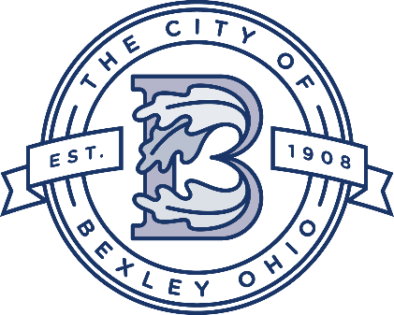

Service Department Update
Service Director
Andy Bashore
December 13th 2022

Street Department:
The crews main focus is leaf removal and will continue until late December. The whole dept. is on leaf removal.The dept. has been working overtime in the evenings and working on Saturdays. The crews are working on the second round through the city.

Water and Sewer Department:
The Water/Sewer crew continues to clean and video the main lines, which is providing data for upcoming lining projects. The crew has been performing repairs on issues that were found when videoing the main lines.

Urban Forestry/Grounds Maintenance:
The tree crew is working on the dog park, drainage has been installed. The fence has been installed and mulch is being spread for the ground covering. The tree crew has started on tree removals and planting. The crews have finished decorating the Drexel Circle.

Drexel Project
Drexel-Main to Broad-The water main line work is complete. Storm inlets have been installed, there are a few to still be installed around CSG, which will be done during the school’s spring break. The concrete work will resume in the spring, which will include curbs, medians, and bump outs. The sewer relining work is 90% complete and will resume in early winter. AEP has started their pole replacement and should be done in late January.

2022 Street Project-
The project is complete.

Chelsea Sewer Relining Project
The project is underway. The project will be complete in early February. The main portion of the project will be in the alley between Chelsea and Grandon.

2022 Sewer Lining Project
The phase 2 lining project will start in mid-January, which include both sanitary and storm sewer work.

2022 Sidewalk Project
The project is finished, the project area was:
Stanwood to Gould in the north and central sections and Vernon to Chelsea in the south.

Service Dept. Highlights

- The traffic engineer is working on an enhanced safety plan for the College Ave.
- The 2022 alley light project has been completed.
- The annual lead and copper testing is complete and the City was in compliance.
- Working on the 2023 working agreement with Franklin Soil and Water.
- Finishing up a street lighting project around the Capital campus.
- The street dept. installed a brick paver walk at Schneider Park.
- The annual fall tree planting project is underway.
- The holiday lights have been installed on Main Street median trees.

