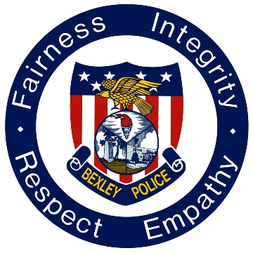

Council Update – Chief of Police

December 13, 2022

Award of Excellence – On December 8th, Detective Justin Fleming was honored by Mother’s Against Drunk Driving (MADD) for his efforts to take impaired drivers off the streets. Det. Fleming serves as the department’s only certified Drug Recognition and OVI Expert. He uses these skills to conduct Standardized Field Sobriety Training (SFST) to officers to better recognize and arrest OVI violators. Although he is now in the Detective Bureau, Det. Fleming continues to work OVI Patrols and assists with DRE calls for both our department other agencies.
Senior Series – Sergeant Overly and Detective Briley participated as panelists in the Senior Living Truth Empowerment Series on December 8th. The event was held at the Gahanna Senior Center and the topic of discussion was "Scams".
Drill – On December 12th, Bexley Police Department partnered with St. Charles High School and other local emergency responders in a full-scale exercise as part of the Ohio Department of Education's state requirements.
RAD – Rape Aggression Defense (RAD) self-defense course wrapped up with a number of citizens who took advantage of the training. More courses to follow in 2023.
Statistics:

Statistics:

