Bexley Board of Zoning and Planning
Staff Report – October 28, 2021
By Kathy Rose, Zoning Officer

a. 934 Euclaire – Variance from front and side yard setback

Application #: BZAP-21-41
Applicant: Amy Lauerhass
Owner: Jennifer and Nicholas Geruntino
Location: 934 Euclaire
Zoning: Medium-High Density Single-Family Residential District (R-6)
Request: The applicant is seeking Architectural Review and approval for a new front porch to replace an awning and an addition of a 1 ½ story structure over an existing flat roof garage.
The applicant is also seeking a variance from Bexley Code Section 1252.09 (R-6) zoning, which required a 30’ front yard setback, to allow the 1 ½ story addition over the attached garage on the east side of the principal structure to encroach 11’1” into the front yard setback along Charles Street side of the property, and encroach 3’8” into the east side yard setback.

FRONT YARD RESTRICTIONS
Bexley Code Section 1252.09 R-6 Zoning
- Front – 30’ feet or average setback as defined in Section 1230.07, whichever is greater
- Side – One-sixth of lot width, but need not exceed 8 feet. However, corner lots must meet additional requirements as stated in Section 1252.10 (lots 50’ to 100 feet it shall be 20 feet).

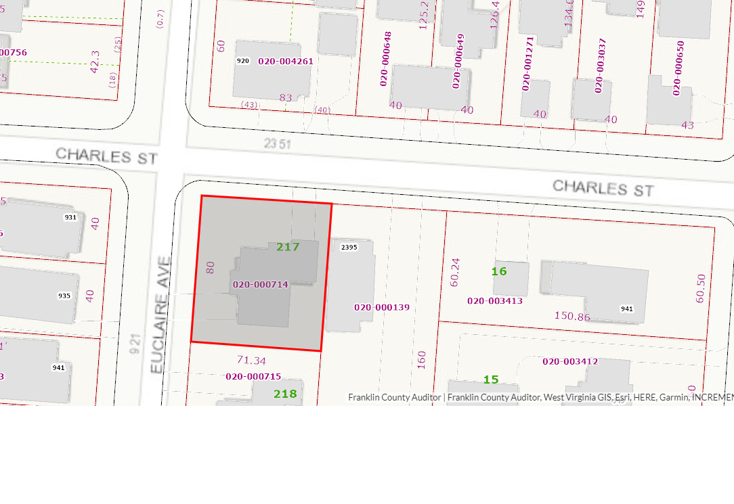

SITE CONSIDERATION
This corner lot, although the front door faces Euclaire, it appears as the front of the house; however, the lot is platted to Charles St., making the north side of this lot the “front yard”.

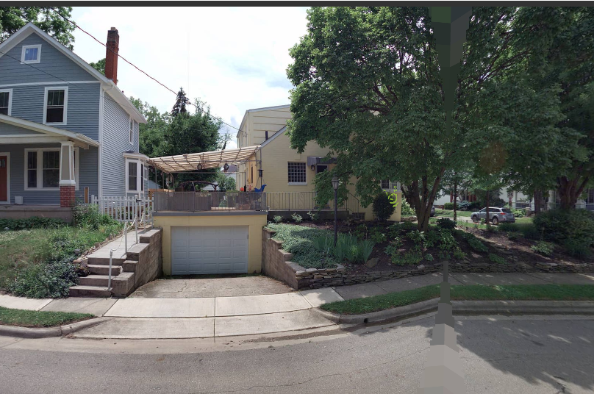 North elevation along Charles
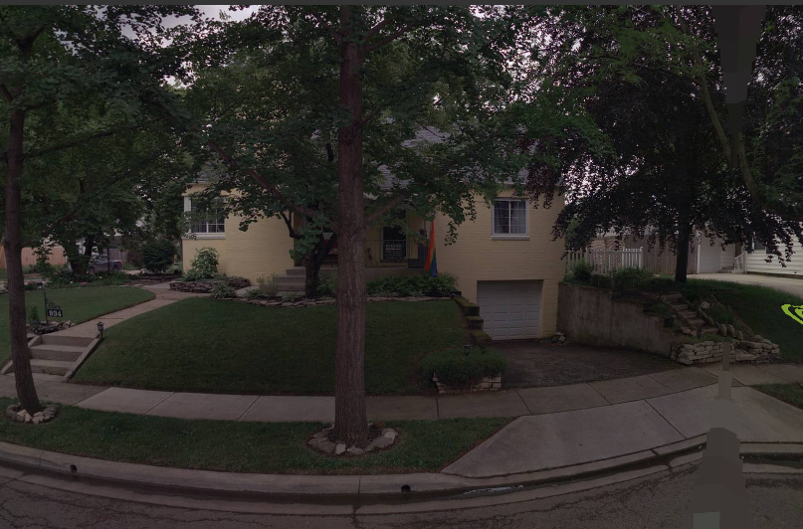
West elevation along Euclaire Ave.

BACKGROUND
The existing lot is 71’ by 80’. This square lot is small in size for a corner lot in the R-6 zoning.

The house has an attached garage on both the south and west sides.
The owner would like to build an addition over the flat roof of the east garage facing Charles Street.
The roof currently has a covered porch. The addition would replace the porch.
The existing garage is also shown at 4’4” from the property line.

- R-6 zoning requires an 8’ side setback from the east side yard property line.
- The Fire Code requires a 5’ separation between structures.

The distance between the neighboring house and bay window have been verified.

I find the unique characteristic of the lot size and configuration of the house, limits the available options without generating a variance.
b. 2371 Bryden – Variance from side yard setback

Application #: BZAP-21-41 START here
Applicant: Amy Lauerhass
Owner: Jennifer and Nicholas Geruntino
Location: 934 Euclaire
Zoning: Medium-High Density Single-Family Residential District (R-6)
Request: The applicant is seeking Architectural Review and approval for a new front porch to replace an awning and an addition of a 1 ½ story structure over an existing flat roof garage.
The applicant is also seeking a variance from Bexley Code Section 1252.09 (R-6) zoning, which required a 30’ front yard setback, to allow the 1 ½ story addition over the attached garage on the east side of the principal structure to encroach 11’1” into the front yard setback along Charles Street side of the property, and encroach 3’8” into the east side yard setback.

FRONT YARD RESTRICTIONS
Bexley Code Section 1252.09 R-6 Zoning
- Front – 30’ feet or average setback as defined in Section 1230.07, whichever is greater
- Side – One-sixth of lot width, but need not exceed 8 feet. However, corner lots must meet additional requirements as stated in Section 1252.10 (lots 50’ to 100 feet it shall be 20 feet).

SITE CONSIDERATION
This corner lot, although the front door faces Euclaire, it appears as the front of the house; however, the lot is platted to Charles St., making the north side of this lot the “front yard”.

North elevation along Charles
West elevation along Euclaire Ave.

BACKGROUND
The existing lot is 71’ by 80’. This square lot is small in size for a corner lot in the R-6 zoning.

The house has an attached garage on both the south and west sides.
The owner would like to build an addition over the flat roof of the east garage facing Charles Street.
The roof currently has a covered porch. The addition would replace the porch.
The existing garage is also shown at 4’4” from the property line.

- R-6 zoning requires an 8’ side setback from the east side yard property line.
- The Fire Code requires a 5’ separation between structures.

The distance between the neighboring house and bay window have been verified.

I find the unique characteristic of the lot size and configuration of the house, limits the available options without generating a variance.

c. 276 S. Stanwood – variance from setback to rear property line

Application Number: BZAP-21-42
Applicant: Joseph Carifa
Owner: Katherine Moss and Simon Doolittle
Location: 276 S. Stanwood
Zoning: Medium-High Density Single-Family Residential District (R-6)
Request: The applicant is seeking Architectural Review and approval to allow a new deck to replace an existing elevated Patio. The applicant is also seeking a variance from Bexley Code Section 1252.11(c)which allows an uncovered deck to encroach 4’ into the 25’ rear yard setback in accordance with Bexley Code Section 1252.09(R-6) zoning. If approved, the deck would be 15.5’ from the rear property line. (the existing elevated patio is 18.5’ from the existing rear property line.)

SITE CONSIDERATION
The existing principal structure is non-conforming in that it is located 15’5” from the rear property line.
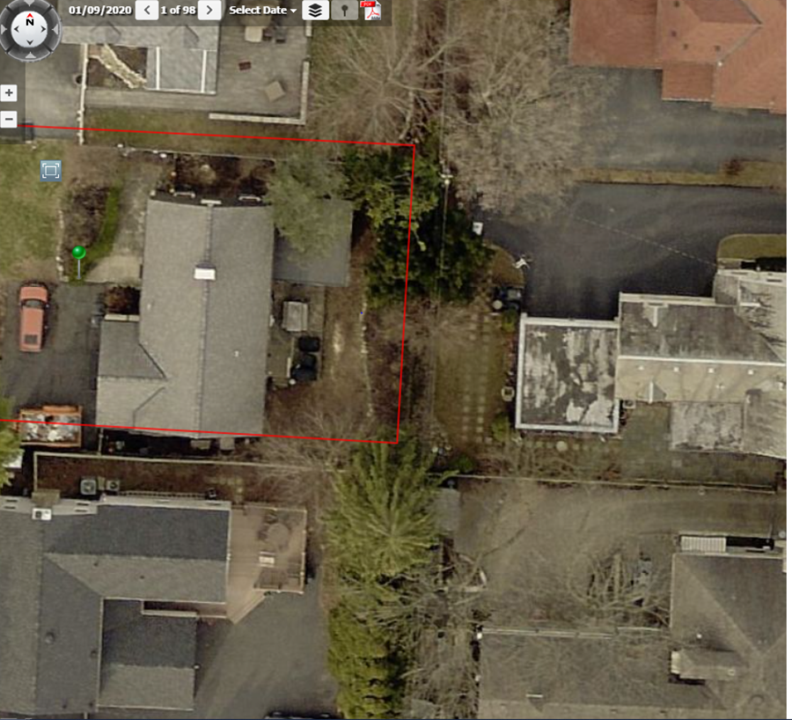
A 25’ setback from the rear property line is required for enclosed living space.

A deck, if uncovered, may encroach 4’ into the rear yard setback. Which would be 21’.

The existing patio is approximately 11’6” x 16’ and 2’ above grade. It does not extend as far to the rear of the lot as the enclosed living space.

The condition of the side walls of the elevated patio appear to have some patched and repaired areas, which may be the reason they wish to remove the structure.

The new deck is proposed at the same level, but will extended to be in line with the rear wall of the principal structure.

The ARB did review, and found that should the Board find it appropriate to grant a variance, it should also include a 6’ fence along the rear property line that will be installed simultaneously with the new deck.

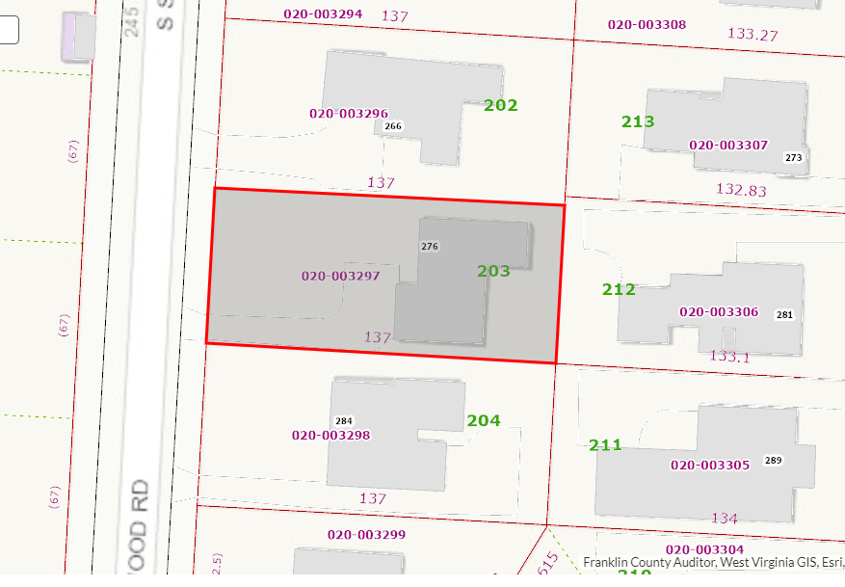

d. 261 S. Columbia - Variance for Circular Drive

Application Number: BZAP-21-45
Applicant: Nathan Sampson
Owner: 261 S. Columbia LLC
Location: 261 S. Columbia Ave.
Zoning: Medium Density Single-Family Residential District (R-3)
Request: The applicant is seeking a from Bexley code Section 1262.06, which allows circular driveways on lots having a minimum front yard width at the street right-of-way of at least one hundred fifty (150) feet along a single street, to allow a circular drive to be maintained and modified on this 140.5’ wide lot.

The applicant currently has an application in front of the Architectural Review Board to replace the existing structure with a new principal structure.

SITE CONSIDERATION
The site plan indicated that they wish to maintain the existing circular drive; however, the placement of the new home is proposed at the same setback as the existing, but reduce the width/size of the of the driveway and add a walkway from the driveway to the front door of the house.
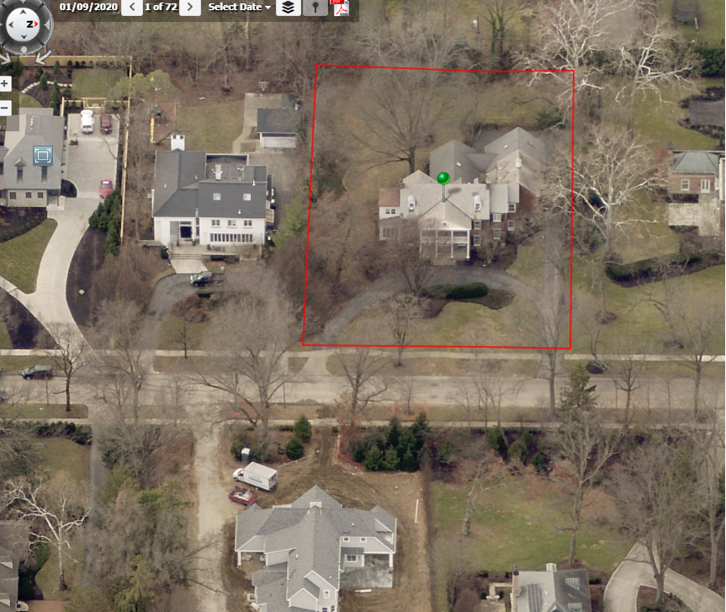

CIRCULAR DRIVEWAYS
Bexley Code Section 1262.06
In the R-1, R-2, R-3, R-6 and R-12 Districts, circular driveways may be permitted on lots having a minimum front yard lot width at the street right-of-way of at least one hundred fifty (150) feet along a single street, provided that said driveways comply with the general regulations, as applicable, set forth in Section 1262.01 and the following additional requirements:
(a) There shall be no more than two (2) points of ingress/egress, which points shall be separated by a minimum distance of at least thirty (30) feet. Meets code
(b) No point of ingress/egress shall be closer than thirty (30) feet from an intersection. Meets code
(c) No circular driveway, exclusive of curb returns, shall exceed 12.5 feet in width. Meets code
(d) The driveway surface shall not occupy more than 25% of the required front yard. Meets code
(e) Circular driveways shall be located so as to avoid damage to or removal of trees within the public right-of-way. Meets code
(f) Circular driveways shall serve as an access corridor leading from a street to a garage or approved off-street parking space. Circular driveways shall not be used for temporary or permanent parking. Meets code
(g) Circular driveways shall require submittal of a stormwater mitigation plan, approved by the City. Meets code as it exists
(h) A permit shall be obtained prior to the installation of a circular driveway.

Staff Points
The lot in question is 8.5’ shy of the required 150’ of lot width.
The circular drive is existing.
The Bexley Tree & Public Garden commission would also need to approve a landscape plan for this property for the proposed new home and if the Board finds it appropriate to grant a variance to allow the applicant to retain the circular drive as modified and shown in the plan dated: August 12, 2021, that it be conditioned on:
- no temporary or permanent parking in front of the house.
-The Board may consider if the lead walk may need to be narrowed in width, to prevent it from being used as a turn around and/or parking space.
-no changes to the drive can happen until a landscape plan is approved by the T&PG.

e. 2450 E. Livingston – Special Permit for fence height

App: BZAP-21-39
Applicant: Michael Grimm
Address: 2450 E. Livingston
Request: The applicant is seeking a special permit in accordance with Bexley Code Section 1264.03(b) which limits fences to forty-eight inches in height in the side yard setback area as it faces a public or private street, to allow a 3.5’ high retaining wall with a 4’ fence on top, for a distance of 43’ along the west side property line along Montrose Avenue.
Background
This property is located at the north east corner of E. Livingston Avenue and Montrose Avenue.
There is a 6’ fence located 10’ behind the city sidewalk along Montrose Avenue. There is also a ____ change in elevation between the existing fence and city sidewalk.

The applicant is trying to expand the rear yard space and also screen the set of large windows on the west side of the house, by adding a retaining wall at the property line, which is approximately 3.5’ behind the city sidewalk and filling in behind the retaining wall level with the rear yard.

I find the overall height to be excessive, at 7.5’ and have asked the applicant to show the setback between the proposed retaining wall and 4’ fence. It could help if they are offset, but it could also look excessive.

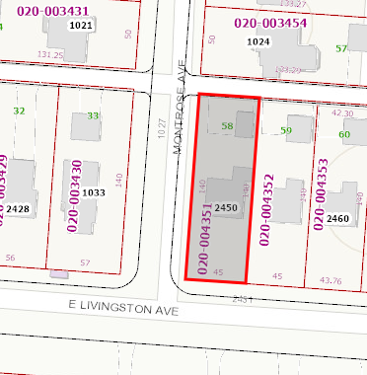
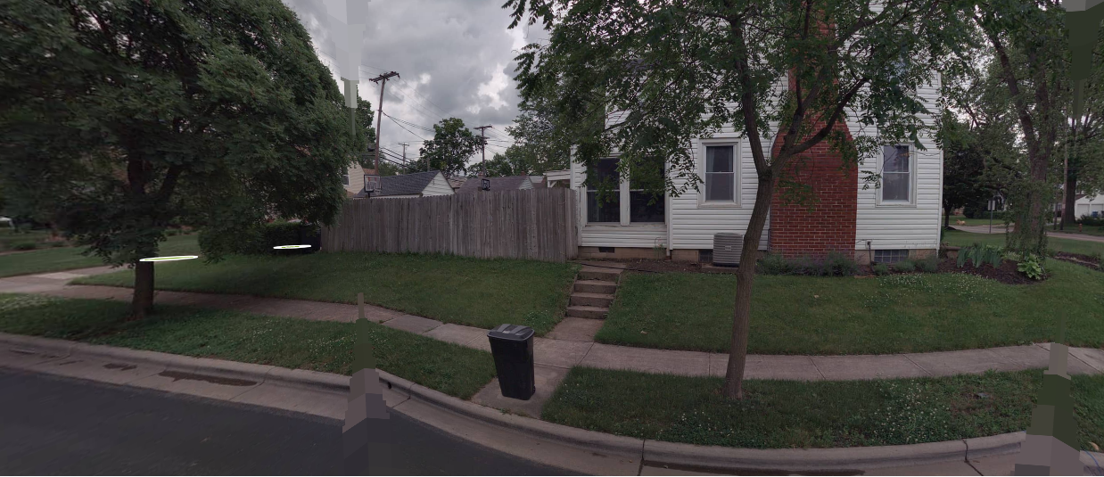

Bexley code Section 1264.03(b) which states No fence, wall or combination thereof shall exceed forty-eight inches in height in the side yard setback area as it faces a public or private street……Fencing or walls exceeding forty-eight inches in height, as measured from the average grade, may be allowed with a special permit from the Board of Zoning and Planning. The Board shall consider the following criteria in reviewing such applications:

- Fence is compatible with other properties in the neighborhood. This property backs up to other front yards along Montrose

- Maximum height not to exceed 72” – Fence and retaining wall is 7.5’
- Fences exceeding forty-eight inches in height should include transparency in the upper 12" to 18" of the fence through the use of latticework, pickets, or other appropriate design elements.- Original submittal did not
(4) A landscaping plan must be filed with the application for a fence permit and approved by the Zoning Officer, indicating how such fencing or wall is to be screened from the street side elevation. The landscape plan should be designed in such a way as to mitigate the impact of a solid fence or wall as it relates to the street and other properties. – The species of plants are not indicated.
(5) The installation of such fence or wall shall not create a visibility or safety concern for vehicular and/or pedestrian movement. – The fence is not to be located near the alley along the north rear property line.
(6) No chain link, wire mesh or other similar material shall be installed on lot lines adjacent to public rights-of-way.- This is a wooden fence
If the Board finds it appropriate to grant a special permit, it should be conditioned upon a specific distance between the retaining wall and fence, and a landscape plan approved by the city landscape consultant.

Prepared by:
Kathy Rose
Zoning Officer

